# Optional: Upload the warehouse dataset to BigQuery

The next video demonstrates how to use COUNT and COUNT DISTINCT in SQL to count and return the number of certain values in a dataset.

If you would like to follow along with the instructor, you will need to log in to your BigQuery account and upload the warehouse data provided as two CSV files. If you haven't set up a BigQuery account, refer to [Using BigQuery](https://www.coursera.org/learn/data-preparation/supplement/DYOQK/using-bigquery).

Download the CSV files:

[Warehouse Orders - Warehouse.csv](https://d3c33hcgiwev3.cloudfront.net/imJai0YnRlyiWotGJ4Zc4g_681d60c67a5c443f90940a3e3b548cf1_Warehouse-Orders---Warehouse.csv?Expires=1623283200&Signature=dmgmFAqHMXzQc-6N7wGik0~FolOC48isEQx8X~QAXSOkhYUWi~KutN8saDW2lz2amsN8lKlh6LGF86FWEHX9uclSuH79gFx3woSRAF0nD~HcmOSBhKBjnNKjEuHrVkLUM5nFSKxDMx1~BdRmg76b9ZVXgB3tE5KhzxGLq46AZZ8_&Key-Pair-Id=APKAJLTNE6QMUY6HBC5A)

[Warehouse Orders - Orders.csv](https://d3c33hcgiwev3.cloudfront.net/7wHK8ZKvRoGByvGSr1aBNw_5433b9c9b98d41b09152b3331141def1_Warehouse-Orders---Orders.csv?Expires=1623283200&Signature=bga0zUfS0vNSWGB4sNuOXFLDMPJFxHGCtMnwpLCNwfwjcx5nZn-nVKz6aa6MXKjgyzSs4VOCf1M7mo0ZRGg8Gm4yC~mAH6nNYZbuAxzVNluT0cEuHHeaZ~YOwwNTEE2C1-pV1PWQlGSxOcdxnoGKfYTk9UM-eRXwDilMR1RSNw0_&Key-Pair-Id=APKAJLTNE6QMUY6HBC5A)

After you download the CSV files, follow Steps 3 through 16 in the [step-by-step instructions for uploading a CSV file to BigQuery](https://scribehow.com/shared/Uploading-a-CSV-file-to__3qDWEO9rS6iORNQN_rBFSw). You will perform Steps 9 through 16 twice (once for each CSV file) to create two tables.

For these particular steps in the instructions, be sure to note and do the following instead:

* Step 5: Instead of clicking CREATE DATASET, click the Actions icon (three vertical dots) next to your project and select Create dataset.

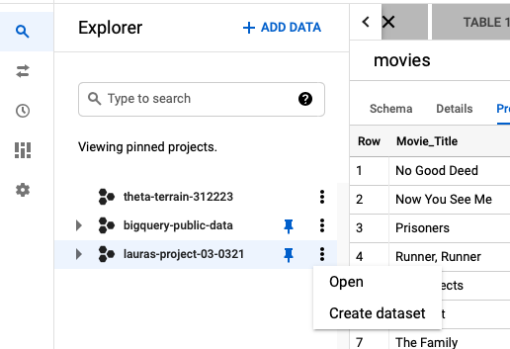

* Step 6: Under Create dataset, for Dataset ID enter warehouse_orders to match the dataset in the video.
* Step 14: Under Destination, for Table name enter Warehouse the first CSV file and Orders for the second CSV file to match the tables in the video.

Finally, to be ready to follow along with the instructor, complete these steps after you upload both CSV files:

1. In the Explorer pane of your BigQuery console, expand your project and navigate to warehouse_orders and then click the Warehouse table.
2. Click the Preview tab to verify that you have 10 rows of data.
3. Click the Orders table.
4. Click the Preview tab to verify that you have 9999 rows of data.

Warehouse Preview:

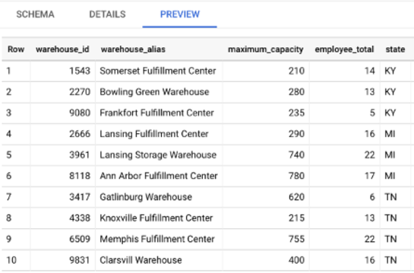

Orders Preview:

